Shelf Space (in feet) (X) Number of Books Sold
1 14
2 18
3 22
4 25
5 30
6 34
7 40
8 43
9 50
10 54

SUMMARY OUTPUT
Regression Statistics
Multiple R | 0.9971
R Square | 0.9942
Adjusted R Square | 0.9935
Standard Error | 1.093
Observations | 10
ANOVA
 | Df | SS | MS | F | Significance F
Regression | 1 | 1650.436 | 1650.4363 | 1380.593 | 3.019E-10
Residual | 8 | 9.563 | 1.1954
Total | 9 | 1660
 | Coefficients | Standard Error | t Stat | P-value | Lower 95% | Upper 95%
Intercept | 8.4 | 0.74691 | 11.24629 | 3.509E-06 | 6.6776 | 10.122
X Variable 1 | 4.472 | 0.12037 | 37.15633 | 3.019E-10 | 4.1951 | 4.750

This regression is very significant; the F-value is 1380.59.
If the X-variable explains very little of the Y-variable, you should get an F-value that is 1 or less. In this case, the explained variation (due to regression = explained by the X-variable) is 1,380.59 times greater than the unexplained (residual) variation. The probability of getting the sample evidence (the X and Y input data) if the X and Y are unrelated (that is the Ho) is .00000000030194. In other words, it is almost impossible to get this kind of data as a result of chance.
The intercept coefficient (Y-intercept) is the b_{o}; in the above problem it is 8.4.
The X Variable 1 coefficient (slope term) is the b₁; in the above problem it is 4.47 (rounded).
The regression equation is: Sales = 8.4 + 4.47 (shelf space).

The correlation coefficient is .997. It is almost a perfect 1. To get 1, all the points would have to be on a line and all the residuals (deviations) would be 0.
The coefficient of determination, r², is 99.4%. There is very little unexplained variation (in fact, the MSE, mean square error is only 1.195).

Another way to test the regression for significance is to test the b₁ term (slope term which shows the effect of X on Y). This is done via a t-test. The t-value is 37.156 and this is very, very significant. The probability of getting a b₁ of this magnitude if Ho is true (the null hypothesis for this test is that B₁ = 0, i.e., the X variable has no effect on Y) is 3.0194E-10 or .00000000030194.

Note that this is the same sig. level we got before for the F-test. Indeed, the two tests give exactly the same results.

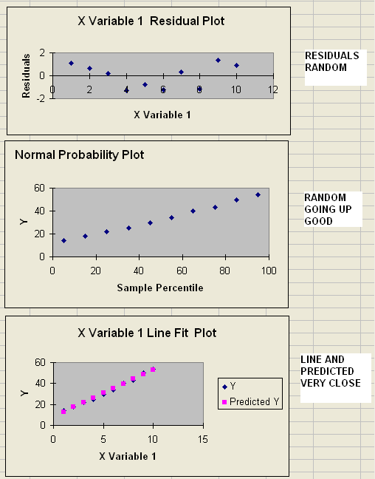
LOW RESIDUALS

RESIDUAL OUTPUT
Observation | Predicted Y | Residuals | Standard Residuals
1 | 12.87272727 | 1.127272727 | 1.093550208
2 | 17.34545455 | 0.654545455 | 0.634964637
3 | 21.81818182 | 0.181818182 | 0.176379066
4 | 26.29090909 | -1.290909091 | -1.252291367
5 | 30.76363636 | -0.763636364 | -0.740792076
6 | 35.23636364 | -1.236363636 | -1.199377647
7 | 39.70909091 | 0.290909091 | 0.282206505
8 | 44.18181818 | -1.181818182 | -1.146463927
9 | 48.65454545 | 1.345454545 | 1.305205087
10 | 53.12727273 | 0.872727273 | 0.846619516

Percentile | Y
5 | 14
15 | 18
25 | 22
35 | 25
45 | 30
55 | 34
65 | 40
75 | 43
85 | 50
95 | 54

